**Level 2 DFD**

1. **Generate Reports**

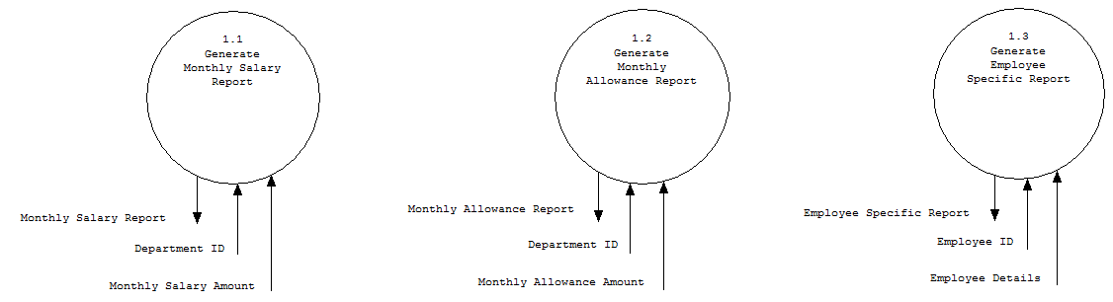

**2.Generate Monthly Salary**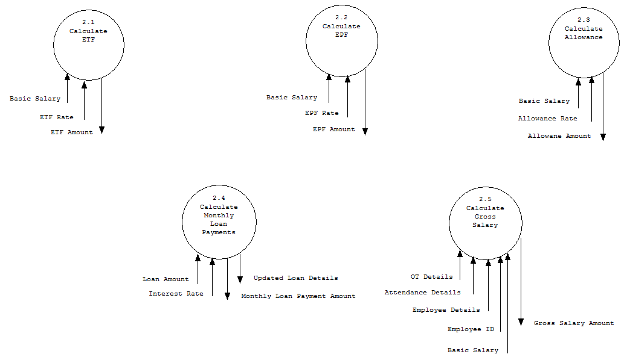

**3.Handling Employee Issues**

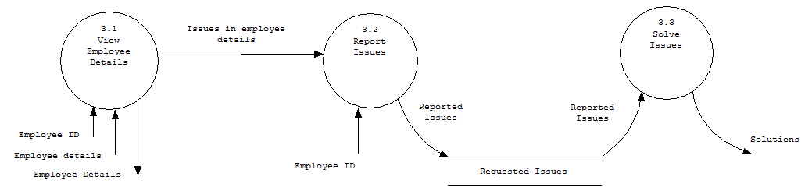

**4. Approve Salary additions & Loan**

